Connecting Acids and Bases with Encapsulation . . .

and Chemistry with Nanotechnology

Activity Supplement
I. General Teacher Notes
A. Information for the Focus Activity
1. Student Background: Prior to the focus activity (“What Makes an Acid an Acid . . .”), students
should have been exposed to certain concepts of solution chemistry such as the meaning of
molarity and the difference between electrolyte and non-electrolyte at the microscopic level.
(It should be noted that Svante Arrhenius originally developed the notion of electrolytes as
charged or ionic substances and non-electrolytes as neutral or molecular substances.) They will
also need to have become familiar with the properties that cause us to classify a material as an
acid and a base and should have some knowledge of examples of these two classes of materials.
- Activity Objective: It should be obvious from the article that the activity set described is
designed to be used as part of a discussion on acids and bases. The goal of the focus activity is
to help students gather the same kind of information that lead Arrhenius to his theory of acids
and bases (which was built off of his more general Theory of Electrolytes).
3. Materials: All materials used in this activity were purchased from Flinn Scientific; they are . . .
a. 24-well reaction plates – AP 1447; $2.95 each
b. Conductivity testers – AP 1493; $19.85 each; these have the advantage over other testers of
being semi-quantitative.
- Magnesium metal – Magnesium turnings, M0004, $13.61 for 100 g.
- Zinc metal – Zinc mossy, Z0003, $9.70 for a 500 g. bottle
- Wood splints – AP4455, $4.10 for 1000
- Test tubes with rims – 15 x 125 mm, GP6015, $39.60 for 72 (this size perfectly fits over the
wells in the reaction plate)
4. Two final notes about this activity:
a. It is very important that the acids be used in exactly the concentrations specified in Part B.
These have been determined to produce the greatest amount of bubble formation for the
different metal – acid combinations without overflowing the wells too greatly.
- The two metal – acid combinations that do not produce a positive test (a ‘pop’ to indicate
hydrogen) with the burning splint are those involving nitric acid. This was included in the
set because the activity-set developer believes that it is important that students become
familiar with anomalies – instances that do not fit a pattern. In this case, the anomaly is a
result of the fact that it is energetically more favorable for the nitric acid to produce nitrogen
dioxide than it is too produce hydrogen. Students observing carefully will see evidence for
this in the form of a production of a yellowish-brown gas in the tubes for these
combinations. Teachers concerned with the impact that this will have on the ability of
students to reach the appropriate conclusion could consider removing these combinations.
- Information for the Explore Activity
1. Student Background: This activity is designed to build off of the first one, but it also requires at
least a basic understanding of the concept of pH. A lesson to cover this concept could be
sandwiched between the focus and explore activities. The discussion in this lesson could be kept
simple by presenting pH as the Power of [the] Hydrogen [Ion], noting that pH is a logarithmic or
power scale similar to the decibel and Richter scales. For solutions of simple concentrations (e.g.
1.0 M or 1.0 x 10⁻³ M), students could be shown that the pH value is equal to the negative of the
power of 10 in the molar concentration.
2. Activity Objective: The goal of the reflect phase is to introduce students to the two sub-classes
of acids (and bases): weak and strong. To frame this activity, the teacher might have bottles of
the strong laboratory acids (hydrochloric, nitric, and sulfuric) at the front of the room, along with
commercial products containing weak acids, such as vinegar (acetic), fruit juices (citric), etc.
- Materials:
a. Magnesium metal – see information in Section A.
b. Marble chips – Flinn Scientific, M0033, $9.20 for 2 kg.
c. Thymol blue indicator – Flinn Scientific, T0045, $7.10 for 100 mL
d. LabPro – Vernier Software, LABPO, $220 each (need LoggerPro Software installed on
computer with which the LabPro is interfaced)
- pH Probe – Vernier Software, PH-BTA, $78.00 each (other probes that a teacher might
already have could be substituted for these and d.)
- Two final notes:
a. One of the biggest pushes in the science education literature recently has been for teachers to
have students use models to explain things more often than typically occurs. This investiga-
tion provides an excellent opportunity to do this as students can be asked to use the
Arrhenius model of acids (molecules that dissociate in water to produce H⁺’s) to account for
the differences between weak and strong acids. Based on this model, the strength of an acid
would be a function of what percentage of the molecules ‘break apart’ in solution. This is
why there is a difference between strength and concentration. A 0.1 M solution of HCl
would have 100% of its molecules dissociated, whereas a 0.1 M solution of HC₂H₃O₂ would
have far, far fewer than 100% of its molecules dissociated.
- Having explained the difference between weak and strong acids (and bases) in a. in terms of
dissociation (building off of the Arrhenius Theory), there is a recognition that this is not the
most modern explanation of the phenomenon. Constructing a description of Bronsted-
Lowry theory at some point ‘down the road’, a teacher could discuss the strong-weak acid /
based distinction again, this time in terms of complete / incomplete ionization and acid-base
equilibria. The author feels that this topic warrants examination a couple of times in an
introductory course due to its importance to not only chemistry but biology as well.
- Information for the Reflect Lesson: Teachers are left to their own devices as to how best to
synthesize the ideas generated in the focus and explore investigations. As noted in the main article,
Volume 3 of Bassam Shakhashiri’s Chemical Demonstrations: A Handbook for Teachers not only
contains some useful demonstrations for getting at some of the concepts at hand, but also has some
excellent background information.
- Information for the Apply Lesson:
1. Student Background: Both as a way to review the ideas of the previous lessons and to provide the
context for this lesson, the teacher might want to begin pre-activity discussion by reminding
students of the Arrhenius Theory, its main points, and how those can be used to provide a
[simplified] explanation of the difference between weak and strong acids and bases. There would
also be a need to introduce students to information about the polymer that will be at the heart of
the work they will be doing; references containing such information are found at the end of the
main article (17. and 18.). It is important that the teacher discuss the nature of the cross-linked
polymer shell that students will form as they drop the solutions / mixtures containing alginate into
the calcium chloride solution; this would offer an opportunity to review / discuss ionic
attractions. Also, it is essential that students have a mental picture of this polymer matrix as
something with ‘pores’ in it and not as a solid sheet, so that they can understand the diffusion of
various species (H⁺ and CO₂) that will be fundamental to understanding their observations.
2. Activity Objective: There are two goals of this activity. The first is to reinforce students’ under-
standing of weak and strong acids and bases by having them use these concepts to account for the
results of their investigation. The second is to introduce them to the phenomenon of encapsula-
tion so that the teacher can infuse a nanotechnology connection by letting students research (in
the extension activity) how nanoencapsulated drugs, nanoreactors, gold nanoshells, etc. are being
developed to be used in the fight against cancer. These nanoscale strategies hold the promise of
more effective treatment of cancers without all of the serious side effects of other methods.
3. Materials:
a. 0.3 M calcium chloride: 100 g. of CaCl₂ . 2H₂O can be purchased from Flinn Scientific for
$7.50 [C0196]. For use in four different introductory chemistry classes, the author made
500 mL of solution which involves dissolving 22.05 g. in 400 mL distilled water and then
diluting to the mark in a 500-mL volumetric flask.
b. Sodium alginate solution: 100 g. of the sodium salt of alginic acid can be purchased from
Aldrich Chemical for $23.30 [18,094-7]. For each class, the author prepared 150 mL of this
solution. This involved weighing out 3.0 g. of the sodium alginate (1.0 g. / 50 mL), putting
150 mL of hot tap water into a 250-mL beaker, and sprinkling the sodium alginate into this hot
water a little bit at a time while stirring. The idea is to avoid excessive clumping of the
polymer which will occur if the water is not hot or the solid is added too quickly. The solution
can still be used if clumps form (they do not need to be filtered), there will just be less alginate
available for capsule formation. Finally, a 1% solution of Congo red indicator is added until
the solution has a distinct red color. [An additional note about this solution: Although this has
not been fully tested by the author, it appears that the effective shelf life of this solution may
only be a couple of weeks before mold begins growing in it.]
c. Gaviscon: This is a commercial product [antacid] which can be found at various drug stores,
Wal-Mart, etc. The author has generally used the Regular strength, cool mint version of this
product. It sells for about $7.69 per 10 oz. bottle, which was enough to supply the Gaviscon
for four introductory chemistry classes. As with the sodium alginate solution, a 1% solution
of Congo red must be added to this mixture until a distinct red color is produced.
d. Vinegar: This is the traditional 5% solution available at grocery stores.
e. Sodium bisulfate: This can be purchased as a solid powder at pool stores as pH Down. The
author found that a good result was obtained if the sodium bisulfate solution was prepared at a
concentration of 10.00 g. of the solid powder per 100 mL of water. It is the one chemical that
deserves some attention as it is a strongly acidic salt. It was chosen because (a) it is
commercially available and represents a non-traditional acid (as it is a solid and students
generally think of acids as liquids) and (b) it is a stronger acid than vinegar and so it gives a
quicker color change and more vigorous bubbling with the spheres. However, students should
be warned that it is strongly acidic and so must be handled with the proper care. After the
students have completed the part 2 testing, these samples should be collected in a common
waste container and neutralized with baking soda before washing the mixture down the sink.
4. Two Final Notes:
a. As noted above, their will be differences between the vinegar and the pH Down in terms of
the rate and extent of color change of the Congo red indicator and the rate and amount of
bubbling. These differences can be explained in terms of vinegar acting as a weak acid and
the sodium bisulfate acting as a strong acid.
- An important question to pose to students is why it is that there is little evidence of the Congo
red indicator diffusing out of the spheres. While this would eventually happen, it is a rather
slow process due to the size of this dye molecule. This will provide further conceptual
background for the students when they move into the extension activity.
- Note about the Biology Version of the Apply Activity: This is included to show how coming at the
same concept (nanoencapsulation) from different angles can allow these nanotechnology-related
activity sets to create inter-disciplinary connections. Additional details about this version (which is
based on the classic starch-iodine diffusion investigation used in many introductory biology classes)
will not be provided here but can be found at the web sites listed in references 22. and 23. in the
main article.
- Information for the Extension Activity
1. Student Background: Students should be first reminded of the phenomenon that they witnessed
in the previous activity – the diffusion of hydrogen ions into the alginate spheres. It should be
discussed with them that the reverse process – diffusion of chemical species out of such spheres –
can take place. This could lead into a discussion of encapsulation at the micro level and such
applications as carbonless copy paper (for background information regarding this, see White,
M.A. “The Chemistry behind Carbonless Copy Paper”, Journal of Chemical Education, 75, 9,
1119 – 1120; see http://mrsec.wisc.edu/Edetc/IPSE/educators/smPapers.html for activities related
to this), scratch-n-sniff stickers (see www.microscent.com/?History for historical background;
see Shultz, E. “Pop-and-Sniff Experimentation: A High-Impact Sensory Teaching Device”,
Journal of Chemical Education, 64, 9, 797 – 798), and even gum (see product information for
Thera-Brand gum at www.therabreath.com.au/prodtbo.html). Of course, one of the most
important applications of micro-encapsulation is in medicine, where the shell of the capsule helps
protect the medicinal compounds in their torturous journey to get into the bloodstream.
From there it is a logical (although technically-challenging jump) to nano-encapsulation.
One application of this that has already been successfully tested in the laboratory is its use in
creating electronic inks (see www.media.mit.edu/micromedia/elecpaper.html for movies of a
version created at MIT; visit www.eink.com/ for the commercial spin-off of this project; and go
to www.sciencentral.com/ then type in electronic paper in the search engine to access articles on
this work). The other major application – and the one which is the focus of the extension activity
– is in medicine. Nano-encapsulated drugs work both by diffusion into the capsule (nanoreactors,
which were mimicked on the macro scale by the capsules in the apply activity) and out of the
capsule (such as the drug Abraxane discussed in the opening paragraph of the main article).
Additionally, the extension activity introduces students to other examples of nanotechnology in
medicine such as Buckyballs (also representing nano-encapsulation), gold nanoshells, and
dendrimers. Numerous resources for the teacher to review in preparation for this activity and the
discussions with students that are likely to ensue are found in the final notes for this activity.
2. Activity Objective: One of the objectives of this activity is to make students aware of the
importance of scale in terms of the technological challenges of moving down (or up) in scale and
in terms of the effect scale has on a particular phenomenon. For instance, moving from micro-
encapsulation to nano-encapsulation required overcoming challenges in the processing involved.
The return for investing the time and money to meet these challenges – at least in medical
applications – is capsules that are at the size scale (and smaller) of the biological entities with
which they are interacting. This has the potential to make nanocapsules more effective.
The other goal is to introduce students to the wide array of nanotechnology-based cancer
diagnostic techniques / treatments being researched at present. For this reason, the extension
activity has a research / presentation format allowing each group to focus on one particular
technique / treatment, while still exposing the class as a whole to the entire set of strategies.
3. Materials: All that is required is access to the Internet for student research.
4. Answers to Questions in 14.:
a. The Congo red has a pH range for its color transition of 3.0 (blue) to 5.2 (red).
b. Both vinegar and sodium bisulfate are classified as acids. Acetic acid is a weak acid, whereas
the bisulfate ion is considered a strong acid. This, of course, implies that they will both
increase the concentration of H⁺ (H₃O⁺) in an aqueous environment as is used in this activity.
- In both cases, the spheres went through a color change. The spheres in the vinegar will not
change completely to blue but will end up some intermediate purplish color, whereas the sodium bisulfate spheres will change completely to blue. In both cases, the color change is
due to the diffusion of H⁺ [H₃O⁺] into the spheres.
- The pure alginate produced no bubbling while the Gaviscon produced bubbling. This is due
to the reaction between H⁺ (H₃O⁺) diffusing in and CO₃⁻² present inside the spheres.
4. Final Notes: Some web sites for teachers to review (some are found in the student hand-out)
a. www.pbs.org/wgbh/nova/sciencenow/3209/03.html -- Based on a PBS program that detailed
the research – and gender struggles of Dr. Naomi Halas, who has pioneered the use of gold
nanoshells to treat cancer. The Cancer Nanotech slide show presents an excellent overview of
different uses of nanotechnology in cancer treatment.
b. www.cancer.gov/cancertopics/understandingcancer/nanodevices -- A section of the National
Institute of Cancer’s web site that contains slides on the use of various nanotechnology
processes in the diagnosis / treatment of cancer
c. http://nano.cancer.gov/resource_center/nano_critical.asp -- Contains a discussion of the value
of using nanotechnology to treat cancer as well as animations of how certain techniques work
d. www.livescience.com/humanbiology/050727_cancer_drug.html – Live Science article on a
cancer drug developed by researchers at MIT and representing an example of nano-
encapsulation
- www.livescience.com/imageoftheday/siod_050523.html – Discusses ‘vaults’ which are
found naturally in many animals – including humans – and someday may be engineered to
deliver drug ‘payloads’
- www.livescience.com/technology/050415_nano_probes.html – Looks at quantum dots and
their potential to act as probes to detect diseased cells
- www.tinhoahoc.com/Nanotechnology/nano-reactor1.pdf#search='nanoreactors' – pdf
document that discusses some research into nanoreactors
- www.arl.army.mil/wmrd/Tech/NanoMat.pdf#search='nanoreactors' – A brief pdf
document that overviews military uses of nano-encapsulation and nanoreactors in
protection against chemical and biological weapons
i. http://nano.cancer.gov/news_center/nanotech_news_2005-10-24c.asp -- Discusses research by
a team in Switzerland showing, in principle, how nanoreactors could be used to fight cancer
j. www.evidenttech.com/qdot-definition/quantum-dot-about.php -- Contains a wonderful
explanation of how quantum dots work (changing quantum-dot-about.php to
quantum-dot-introduction.php takes you to a series of animations on this topic)
II. Student Activity Hand-out and Evaluation Rubrics
Introductory Chemistry Name_____________________________
Activity Set, Investigation 1 Date _____________________________
What Makes an Acid an Acid? (and a Base a Base for That Matter?)

Introduction
Recent activities and discussions have introduced you to two very important classes of chemicals:
Acids and bases. You have become familiar with some of the properties which cause chemists to place a
material into one of those two classes and become familiar with some common examples. However, for
chemists (and for you), it is not satisfactory to create such categories and to organize things into them; they
(and you) are usually more interested in explaining what causes such categories to exist. In this activity,
you will be able to gather the clues necessary to provide such an explanation for acids and bases.

Procedure
- Gathering Clue #1 about Acids
- Obtain a 24-well reaction plate, a wash bottle containing distilled water, and a conductivity tester.
- Working in Row A for this part, fill each of the first four wells ~half way with distilled water.
- Unpack your conductivity tester (C.T.) and turn it on. Test each of the four distilled water samples
with it. If any of them show a significant level of conductivity, remove the distilled water from the
well with a plastic pipet, clean the well out with a Q-tip, and then replace the distilled water in it.
- You and a partner group should share dropping bottles of the four acids with which you are going
to work in Parts A. and B.: Hydrochloric (3 M); nitric (3 M); phosphoric (3 M) and sulfuric (3 M).
Gather up dropping bottles containing these four acids (read the concentration value carefully).
- Add 3 drops of [3 M] hydrochloric acid to the distilled water in the well 1 of row A., add 3 drops of
[3 M] nitric acid to well 2 of row A, add 3 drops of [3 M] phosphoric acid to well 3, and add
3 drops of [3 M] sulfuric acid to well 4.
- Place the C.T. in the liquid in well 1, use the copper electrodes to mix in the drops of hydrochloric
acid, and then record the conductivity level. Rinse off the electrodes with distilled water.
- Repeat the process described in step 6. for the liquid mixtures in the other three wells.
- After you have recorded all of your data, turn the battery power off on the C.T., rinse off the copper
electrodes one last time with distilled water, then clean them with steel wool, and box the C.T. up.

Data
Acid Tested | Conductivity Level
1. Hydrochloric
2. Nitric
3. Phosphoric
4. Sulfuric

Part A. Follow-up Questions (Show your answers to these to your instructor before moving on)
1. What is true of the conductivity of the acids you tested (and acids in general)? What does this tell
you about the microscopic nature of acid solutions? (i.e. Of what must acid solutions be made?)
- One of the properties of all acids is that they taste sour. What would have to be true (at the micro-
scopic level) of acids to allow them all to taste the same?
3. What overall conclusion about what makes an acid an acid can you draw from Part A.?
- Gathering Clue #2 about Acids
- Obtain the following materials: Two small test tubes which have a mouth size with the same
diameter as the wells of your reaction plate, several (3 – 4) wooden splints, a cup of mossy zinc,
and a cup of magnesium turnings. (The last two items can be shared with your partner group.)
- You are going to be studying the reaction between the two metals in the materials set (zinc and
magnesium) and the four acids that you tested in Part A. One problem is that three of the four
acids – hydrochloric, nitric, and sulfuric – require a higher concentration to produce a testable
amount of gas with the zinc than to produce an equivalent amount with the magnesium. As a
result, you will be using all 3 M solutions of the acids to react with the zinc, but 1 M solutions of
the acids to react with the magnesium (except for the phosphoric acid, which will still be 3 M). To
that end, obtain dropping bottles of 1 M hydrochloric, nitric, and sulfuric acids (share these).
- To make the testing process more clear, a very specific set of directions as to what acid solution to
place in what well follows. Make sure that you use the acid straight from the dropping bottle (do
not dilute it with distilled water) and that you fill each well ~half way with the designated acid . . .
a. Hydrochloric: 3 M in row A, well 6 and 1 M in row B, well 5
b. Nitric: 3 M in row B, well 1 and 1 M in row B, well 3
c. Phosphoric: 3 M in row C, well 6 and 3 M in row D, well 5
d. Sulfuric: 3 M in row D, well 1 and 1 M in row D, well 3
- Place 1 – 2 pieces of mossy zinc into the row A, well 6 sample of hydrochloric acid and several
(~a half-dozen) pieces of magnesium turnings into the row B, well 5 sample. Immediately cover
the wells containing both of these reaction mixtures with the small test tubes (inverted).
- Allow the reactions occurring in each well to proceed for ~1 minute; record observations during
that time period. At the end of reaction time, light a wooden splint, lift one of the two test tubes
from its position covering the well (keep it inverted) and bring the burning splint to its mouth.
Record observations and then repeat this test for the other test tube.
- Continue through the other three pairs of acid samples in the manner outlined in steps 4. and 5.:
Place mossy zinc in the 3 M member of the pair, magnesium turnings in the 1 M member, and
cover both reaction wells with test tubes (you can use the same 2 test tubes throughout). After the
1-minute reaction time, light a wooden splint, lift the test tube off of the well and bring the burning
splint to its mouth. Make sure to compare the results of this testing between the different acids.
- To clean up, pick the pieces of mossy zinc out and place them in a recovery beaker, scrape the
leftover magnesium into the garbage can, and rinse the remaining liquids down the sink.

Data Table
Acid Tested | Observations with Zn Metal | Observations with Mg Metal
1. Hydrochloric
2. Nitric
3. Phosphoric
4. Sulfuric
Follow-up Questions for Part B.
1. What was the most common result(s) of the testing you did in this section? What does this indicate
about the gas(es) produced by these metal-acid combinations? Where did this gas come from?
2. Did all of the metal-acid combinations produce the same result? If not, what did you notice that
was different about the one(s) that did not?
3. Draw an overall conclusion: Why do all acids have the same set of properties?
C. Gathering Clue #1 about Bases
1. You are basically going to repeat the procedure you undertook in Part A., except that you will be
testing several different bases. To that end, obtain a clean 24-well reaction plate and unpack your
conductivity tester.
- Repeat steps 2. and 3. of Part A.
- Gather the following four base solutions: Sodium hydroxide (2 M), potassium hydroxide (2 M),
sodium carbonate (washing soda, 1 M), potassium carbonate (potash, 2 M). Share these with your
partner group.
- Add 3 drops of sodium hydroxide solution to the distilled water in well 1, 3 drops of potassium
hydroxide solution to the distilled water in well 2, 3 drops of sodium carbonate solution to well 3,
and 3 drops of potassium carbonate solution to well 4.
- Test the conductivity of these liquid mixtures as you did in steps 6. and 7. of Part A.
- Clean up as you did in step 8. of Part A.
D. Gathering Clue #2 about Bases
1. Use row C. of your 24-well reaction plate. Place ~15 drops of each of the four base solutions being
studied in a different well of this row; keep them in the order they appear in the Table below.
- Obtain a dropping bottle of 0.1 M ferric [iron (III)] nitrate solution. Add ~6 drops of this reagent
to each of the four base-solution samples and record your observations in the Table below.
- Clean out your 24-well reaction plate and leave it turned upside down on paper toweling to dry.
Data Table
Base Tested | Conductivity Level | Result with Iron Nitrate
1. Sodium hydroxide
2. Potassium hydroxide
3. Sodium carbonate
4. Potassium carbonate
Follow-up Question: What makes a base, a base and how did the information you gathered in
this section lead you to this conclusion?
Introductory Chemistry Name_____________________________
Activity Set, Investigation 2 Date _____________________________
Not All Acids [and Bases] Are Created Equal
Introduction
While most people have heard of the terms acid and base, few people have a genuine understanding
concerning what these terms refer to other than being able to identify familiar materials belonging to each
category. Hopefully, your own understanding of that term is now much deeper, as you should not only be able to provide examples of each of those two classes of substances, but you should also be able to identify
some of the characteristics by which we place things in each class. Additionally, you should have achieved one of the most sought after goals in chemistry: A molecular-level explanation of why all acids and why all
bases act alike. That explanation is in the form of one the earliest models to account for the behavior of acids and bases: The Arrhenius Theory. It explains the properties of these materials by suggesting that
acids are materials that dissociate in water to produce hydrogen ions [H⁺] and bases are materials that
dissociate in water to produce hydroxide ions [OH⁻⁻]. This allows you to understand the meaning of pH as
the power of hydrogen: The concentration of hydrogen ions in a solution written as its power of ten value.
Your foray into this topic will be complete when you are able to recognize that even though all of
the materials we call acids share a common set of chemical properties, there are differences within the
members of this class of compounds; that also holds true for bases. Though those differences may seem
subtle on the surface – as you may soon discover – they have a profound impact in the way we use – and
handle – different acids and bases. You will hopefully leave this activity with an appreciation for those
differences – and with the microscopic explanation of why those differences exist.
Procedure
- Obtain a clean 24-well reaction plate.
- You will need to find beakers containing 1 M solutions of the following four acids: Acetic, citric,
hydrochloric, and nitric. (You and a partner group can share a set of these acid solutions.) Answer
these questions concerning this set of solutions:
- What does the “1 M” indicate? Be specific.
- Since all of the solutions in this set are “1 M”, what does that mean about these four solutions?
- Locate row A. of your reaction plate and fill the first well in it no more than one-third of the way
with the acetic acid solution, the second well no more than one-third of the way with citric acid, the
third well no more than one-third of the way with hydrochloric acid and the fourth well no more
than one-third of the way with nitric acid.
- Fill rows B. and C. in exactly the same manner as you filled row A.
- Row D. will be filled with the same sequence of acids (acetic, citric, hydrochloric, and nitric);
however, each well in this row should be filled up approximately half way.
- Obtain a cup containing magnesium metal turnings and an accompanying scoopula. Transfer 8 -10
magnesium turnings into the acid [acetic] solution in well 1 of row A. and observe. Repeat with
the other three wells in this row; try to place the same number of magnesium turnings in each.
Record your observations in the Data Table, then answer the questions below:
- What signpost of a chemical change is there in these wells?
- What substance is being produced that results in that signpost being observed?
- Did all of the acid samples react the same way? Should they? If they didn’t, why didn’t they?
- Obtain a cup containing marble chips (calcium carbonate) and a pair of tweezers. Transfer 1 – 2
marble chips into the acid [acetic] solution in well 1 of row B. and observe. Repeat with the other
three wells in this row. Record your observations in the D. T., then answer the questions below:
- What signpost of a chemical change is there in these wells?
- What substance is being produced that results in that signpost being observed?
- Did all of the acid samples react the same way? Should they? If they didn’t, why didn’t they?
- Obtain a dropping bottle containing thymol blue indicator. Add 3 – 5 drops (enough to produce a
distinct coloration) of this indicator solution to the acid [acetic] in well 1 of row C. and observe.
Repeat with the other three wells in this row. Record your observations in the Data Table, then
answer the questions below:
- This is an acid-base or pH indicator; what is the pH range(s) over which this indicator changes
color and what are the colors it changes between?
- Use the information you just filled in for a. to estimate the pH values or the range of values for
each of the four acid solutions. Are the pH values the same for each? Should they be?
- Set up a pH Probe – LabPro System and proceed through the necessary steps to calibrate this
equipment to read pH (refer to the accompanying “Calibrating the pH Probe” hand-out). Place
the pH probe in the acid [acetic] solution in well 1 of D., then read and record the pH value once
it stabilizes. Remove the probe from this sample, rinse it off thoroughly with distilled water, and
then place it in the acid [citric] solution in well 2. Read and record the pH value. Repeat for the
other two acid [hydrochloric and nitric] solution samples. After you have recorded all of the pH
values in the Data Table, answer the questions below:
- What does pH stand for? What is being measured by the pH value?
- Based on the questions you were asked in 2., how should the pH values of the four solutions
compare to each other? Explain your answer.
- If the four values do not compare in the manner that you suggest in b., offer an explanation for
why they might not.
Data Table
Property Tested | Acetic Acid | Citric Acid | Hydrochloric Acid | Nitric Acid
1. R_{x} with Mg
turnings
2. R_{x} with marble
chips
3. Thymol blue
indicator
4. pH probe
reading
Experimental Investigations into the Nature of Acids and Bases
Laboratory Evaluation Rubric
Group Members: ________________________ _________________________
________________________ _________________________
Rubric Element Score Spectrum
- Collected accurate data concerning the conductivity 0 1 2 3 4
of acids in Part A. of the “What Makes an Acid, an
Acid?” activity
- Formulated a valid conclusion from the results of the 0 1 2 3 4 5
of the cond. testing in that activity
- Collected accurate data concerning the reaction of 0 1 2 3 4
of acids with metals in Part B. of the “What Makes
an Acid, an Acid?” activity
- Formulated a valid conclusion from the results of the 0 1 2 3 4 5
of the metal R_{x} / splint testing in that activity
- Responded adequately to the questions concerning 0 1 2 3 4
the meaning of 1 M in the “Their Not All Created
Equal” activity
- Collected thorough observations and responded well 0 1 2 3 4
to the questions concerning reactions with Mg and
CaCO₃ in the “Their Not All . . .” activity
- Collected thorough observations and responded well 0 1 2 3 4
to the questions concerning indicator and pH measure-
ments in the “Their Not All . . .” activity
- Proposed a reasonable and logically-sound explanation 0 1 2 3 4 5
for the result of that activity which was based on
prior knowledge
Points Achieved: __________
35
Comments:
Possible Points: __________
Introductory Chemistry Name_____________________________
Activity Set, Investigation 3 Date _____________________________
Encapsulation – in Chemistry and Beyond
Introduction
It has been said that you truly understand something when you are able to explain it clearly to
others. Most scientists would probably say that you truly understand a scientific concept when you are able
to use it to explain a new instant of that concept or to predict the outcome of a situation that involves that
concept. For this activity, you will be held up to the second view of what it means to ‘understand’
something. That something is weak and strong acids and bases and, in the simplest terms, what you will be asked to do in the investigation that follows is to apply your understanding of these terms to a model system. That model system will introduce you in a very visible way to the phenomenon of encapsulation –
the trapping or confining one chemical / material in another.
There are examples of encapsulation all around you: Scratch-n-Sniff stickers, carbonless copy paper
(such as when you sign a receipt), and pressure-activated adhesives (such as Scotch-Grip™ by 3M).
Perhaps the most significant of the applications of encapsulation is in the realm of medicine, where drug
molecules are [micro-] encapsulated so they can survive the journey into the digestive system where they
can be released at the appropriate time into the blood stream. Taking this process down one scale – into
nanoencapsulation – may give doctors a safer and more efficient weapon to use in the war on cancer.
Clearly, though, before you can understand how such applications work, you first need to see what
encapsulation is and the kind of chemical process associated with it. To that end, you will study a model system (a simple example that can be used to represent more complicated cases. That system will involve forming capsules (from here on referred to as macrospheres) by combining a solution of sodium alginate
(a commercially useful polymer obtained from seaweed) with a solution of calcium chloride. To
appreciate how this formation will occur, think of the sodium alginate in the solution as spaghetti strands
laying on a plate: They are all separate from each other (assuming you are a good cook) and they are
randomly organized; this is why the solution is a liquid. These strands of sodium alginate have carboxyl
groups (a combination of a carbon atom and two oxygen atoms carrying a single negative charge) sticking
out of them every so often. When you combine this solution with the calcium chloride solution, calcium
ions (Ca⁺², with a double positive charge) are able to grab onto carboxyl groups from two different
strands and form a ‘bridge’ between them. This process – known as cross-linking – produces something
akin to a spider’s web, with the alginate polymer strands representing the main threads and the calcium-
carboxyl bridges serving as the connecting threads. The
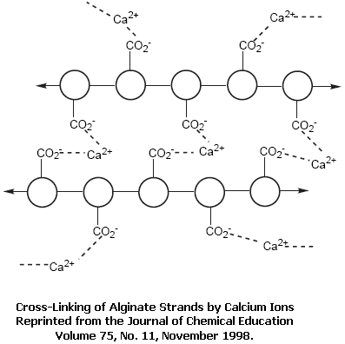
bottom line is that it organizes the polymer strands and
results in the formation of a gel-like material. See the
picture to the right.
There will be two different sources of the sodium
alginate for creating this model encapsulated system. One
will be a solution made of pure sodium alginate dissolved in
water. The other will be Gaviscon, a commercial antacid that
contains sodium alginate (as a thickening agent), but also
contains several other chemicals including the two active
ingredients. These two sources will be compared; they will be compared by looking at what happens
when the macrospheres created from them are transferred from the solution in which they are created into
(1) vinegar and (2) a solution made from the commercial product pH Down (which is mostly the
compound sodium bisulfate and is used to lower the pH of pool water).
How will you make these comparisons, though? The most important thing for you to remember
going into this investigation is that the sodium alginate and Gaviscon both will have had Congo Red
indicator added to them by your instructor. The molecules of this indicator will become encapsulated in
the alginate macrospheres when they are formed. Once you transfer these macrospheres to the vinegar
and pH Down solutions, the indicator trapped in them – as well as your keen observations – will allow
you to follow the course of events. Your goal will be to note similarities / differences between what
occurs in the vinegar and what occurs in the pH Down solution. Likewise, you should be making
comparisons between the pure alginate spheres and the Gaviscon spheres.
As you do what was described in the previous paragraph, keep two things in mind. First, as was
stated at the outset of this Introduction, this activity is [partially] designed to give you a chance to firm up
your understanding of ideas related to the chemistry of acids and bases. Second, as you put your
knowledge of acids and bases to good use, you should be thinking about what is going on inside and
outside the macrospheres. This will be an important first step towards being able to see how encapsula-
tion can be used in some many wonderful applications.
Procedure
1. Obtain a 6-well reaction plate, a 5” x 8” index card, and a pair of tweezers.
2. From the chemical storage area, obtain a beaker containing 0.3 M calcium chloride [CaCl₂].
3. Consult the picture below throughout the remainder of this investigation as a reference . . .
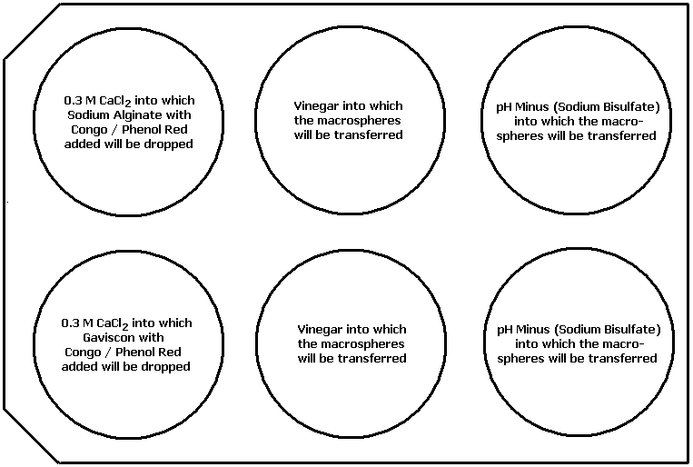

- Lay your 6-well R_{x} plate on the 5” x 8” index card in the orientation shown in the drawing above.
- Pour the 0.3 M calcium chloride solution into the left-hand-most (i.e. first) well in each of the two
rows until the well is about ¾ of the way full.
- Obtain a beaker of sodium alginate with Congo Red indicator mixed into it. Draw some of this
mixture up into a pipet. Hold the pipet a few centimeters above the surface of the CaCl₂ solution
in the well in row 1 and begin releasing drops of the alginate-indicator mixture into it. Release
~12 drops. Record observations about the spheres produced. What is trapped in these spheres?
- Repeat step 6. but this time use a beaker containing Gaviscon with Congo Red indicator mixed
into it and release the drops of this mixture above the surface of the CaCl₂ in the well in row 2.
Again, record your observations. What is trapped in these spheres?
- Obtain a beaker containing vinegar. Fill the middle well in each of the two rows of your reaction
plate about ¾ of the way with vinegar.
- Obtain a beaker containing pH Minus (sodium bisulfate, NaHSO₄). Fill the right-hand-most
[last] well in each of the two rows of your reaction plate about ¾ of the way with this solution.
- Rinse your pair of tweezers. You should have noticed the formation of macrospheres in well 1
of each of the rows. Use the tweezers to carefully pick up half (~6) of the macrospheres in well
1 of row 1 (formed from the pure sodium alginate) one at a time and transfer them into the
vinegar in the middle well of row 1. What is surrounding these spheres? Make observations of
any immediate changes that take place.
- Transfer the other half (~6) of the macrospheres in well 1 of row 1 into the pH Minus in the right-
hand-most [last] well of row 1. What is surrounding these spheres? Make observations of
any immediate changes that take place.
- Repeat the transfer described in 10. and 11. for the macrospheres in well 1 of row 2 (formed from
the Gaviscon), moving half of them into the vinegar in the middle well of row 2 and half of
them into the pH Minus in the last well of row 2. Again, make notes of any immediate changes.
- You are asked to check on the systems in the two middle wells and in the two right-hand-most
wells as you answer the questions below and then record additional observations.
- Answer these questions concerning the procedure you just completed:
a. What is the pH range and color change(s) of Congo Red indicator?
b. What do you know about the chemical nature (properties) of vinegar? What about sodium
bisulfate (the main ingredient in pH Minus)? What is similar about them? What is different?
c. What was similar about the changes that occurred when the alginate / Gaviscon macrospheres
were transferred to vinegar and when they were transferred to pH Minus? What was different
about the changes? What was happening [chemically] to produce those changes?
d. What was different about what happened to the Gaviscon macrospheres compared to what
happened to the alginate macrospheres when they were put into the two different solutions?
Provide an explanation for this. (Hint: Look at the ingredients list on a bottle of Gaviscon.)
- Clean up the contents of the reaction plate by rinsing them down the sink with ample water.
Data Table
Step | Observations | Answers to Questions
6.
7.
8.
9.
10.
11.
12.
Biology I Name____________________________
Activity Set, Investigation 1 Date ____________________________

A Model system for studying the movement of molecules
Introduction
Cancer . . . It is a word that strikes fear in the hearts of most individuals. Each year it is responsible
for the death of over a half million people in the United States. Despite years of research into its causes and ways to combat it, the strategies for fighting cancer have not changed much from the 20th into the 21st century: The two main methods are still radiation and chemotherapy. As you are probably aware, both of
them can have serious side effects: Hair loss, fatigue, and nauseas to name a few. This is a result of the fact
that both treatments kill healthy (‘good’) cells as well as cancerous (‘bad’) cells. In other words, using a
military analogy, these weapons cause a lot of collateral damage.
The ideal weapon would be one that targets only the cancer cells and leaves healthy cells unscathed.
With the onset of the 21st century, researchers have begun to develop such weapons. One way by which such ‘smart bombs’ accomplish their objective is through the use of encapsulation technologies. In this approach, the chemotherapeutic agent (cancer-killing compound) is trapped inside a sphere. On the outside of the sphere, other molecules are attached that cause the sphere to specifically ‘stick’ to only cancer cells.
The spheres travel through the body, reach the cancer cells, attach themselves to these cells, and then deliver
their deadly payload – all without affecting nearby healthy cells.
Why that all sounds simple in theory, in practice there are tremendous technological challenges to
overcome: How do you get the drug compound inside the sphere?; What are the right molecules to attach to
the sphere to ensure that only cancer cells are targeted?; and How can you make sure the drug compound
gets properly released into the cancer cells? These are questions with which researchers are and will
continue to struggle. They represent challenges that will likely still be around to be solved when you
graduate from high school and consider a career to pursue. Perhaps you will someday be on a team that
accepts such a challenge and produces the next breakthrough in the war on cancer.
First things first, though: You need to learn some basic science to be able to gain some insight into
how such strategies work and that is the goal of this activity. In simple terms, you are going to study the
process of encapsulation – the trapping of substances inside a rigid structure – and what happens to the
substances trapped inside when the environment around the capsule changes. To that end, you are going to create a model system – a simple example that can be used to represent more complicated systems – to study. The ‘shell’ for that model system will be prepared by combining a solution of sodium alginate (a
polymer obtained from seaweed) with a calcium chloride solution. To understand how this formation will
occur, think of the sodium alginate in the solution as all of the individual fibers in a spider’s web: They are
all separate from each other and are randomly organized; this is why the solution is a liquid. These strands
of sodium alginate have carboxyl groups (a combination of a carbon atom and two oxygen atoms carrying a
single negative charge) sticking out of them every so often.
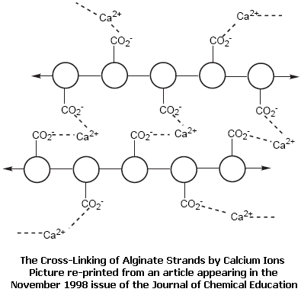
When you combine this solution with the calcium chloride
solution, calcium ions (Ca⁺², with a double positive charge)
are able to grab onto carboxyl groups from different strands
and form ‘bridges’ between them. This process, known as
cross-linking, produces connections between strands, much
as a spider strings together the separate fibers in its web. The
bottom line is that it organizes the polymer strands and results
in the formation of a gel-like material. See the picture to the
right to give you a molecular view of this material.
There will be two different sources of the sodium alginate for creating this model encapsulated
system. One will be a solution made of pure sodium alginate dissolved in water. The other will be
Gaviscon, a commercial antacid that contains sodium alginate (as a thickening agent), but also contains
several other chemicals including the two active ingredients. These two sources will be compared.
Another thing that will be compared is how the nature of what species are trapped in the capsules
and the nature of what species are found in the surroundings affect the actions of these capsules. To
explore this, you will trap either iodine (the simple molecule I₂) or starch (a complex polymer structure
built up from glucose units) in the capsules (macrospheres) and have the opposite one in the surroundings. The pairing of iodine with starch forms a complex combination with a distinct purplish-black coloration. Observing where that combination appears will provide you with insights into the
molecular processes that go on inside and outside of the macrospheres. This will introduce you to an important biological phenomenon that occurs in cells. It will also be the first step towards understanding
how encapsulation can be used in the battle against cancer.
Procedure
1. Obtain a 6-well reaction plate, a 5” x 8” index card, and a pair of tweezers.
2. From the chemical storage area, obtain a beaker containing 0.3 M calcium chloride [CaCl₂].
3. Consult the picture below throughout the remainder of this investigation as a reference . . .

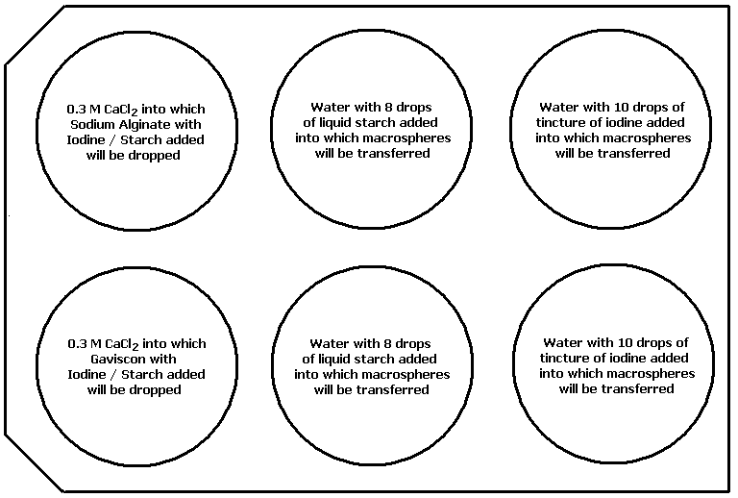

4. Lay the reaction plate on the 5” x 8” index card in the orientation shown in the drawing above.
5. Pour the 0.3 M calcium chloride solution into the left-hand-most (i.e. first) well in each of the two
rows until the well is about ¾ of the way full.
6. Obtain a beaker of sodium alginate with iodine mixed into it. Draw some of this mixture up into
a pipet. Hold the pipet a few centimeters above the surface of the CaCl₂ solution in the well in
row 1 and begin releasing drops of the alginate-iodine mixture into it. Release ~10 drops.
Record observations about the spheres you produce. What is trapped in these spheres?
- Repeat step 6. but this time use a beaker containing Gaviscon with iodine mixed into it and
release the drops of this mixture above the surface of the CaCl₂ in the well in row 2. Again,
record your observations. What is trapped in these spheres?
- Fill the middle well in each of the two rows of your reaction plate about ¾ of the way with water.
Obtain a beaker of liquid laundry starch. Draw some of this suspension up into a pipet. Release
about 6 – 8 drops of it into each of these two wells, then stir the contents of the well to mix the
starch into the water.
- Obtain a pair of tweezers. You should have noticed the formation of macrospheres in both wells
as the result of the sodium alginate mixing with the calcium chloride and going through the
cross-linking process described in the Introduction. Use the tweezers to carefully pick up the
macrospheres in well 1 of row 1 (formed from the pure sodium alginate) one at a time and
transfer them into the starch-water mixture in the middle well of row 1. What is surrounding
these spheres? Make observations of any immediate changes that occur in this system.
- Repeat the transfer described in 9. for the macrospheres in well 1 of row 2 (formed from the
Gaviscon), moving them into the starch-water mixture in the middle well of row 2. What is
surrounding these spheres? Again, make observations of any immediate changes.
- You are asked to check back on the system in the two middle wells periodically as you proceed
through the next few steps and to record additional observations.
- Repeat step 6. above, except this time, use a beaker containing sodium alginate with starch
mixed into it. After you have released ~10 drops of this mixture into the CaCl₂ solution in well
1 of row 1, make observations of what happens. What is trapped in these spheres?
- Repeat step 7. above, except this time, use a beaker containing Gavison with starch mixed into
it. After releasing the drops (into well 1 of row 2), make notes. What is trapped in these spheres?
- Fill the right-hand-most [last] well in each of the two rows of your reaction plate about ¾ of the
way with water. Obtain a beaker of iodine (either tincture of or Graham’s). Draw some of this
solution up into a pipet. Release about 8 – 10 drops of it into each of these two wells, then stir
the contents of the well to mix the iodine into the water.
- Rinse off your tweezers from the work in steps 9. and 10. Use them to transfer the spheres formed
in well 1 of row 1 (in step 12. above) into the water-iodine mixture in the last) well of row 1.
What is surrounding these spheres? Make observations of any immediate changes taking place.
- Repeat the transfer described in 15. for the macrospheres in well 1 of row 2 (formed from the
Gaviscon), moving them into the starch-water mixture in the right-hand-most [last] well of row
2. What is surrounding these spheres? Again, make observations of any immediate changes:
- Allow this system to ‘operate’ for a few minutes, then make a final set of observations.
- Answer these [additional] questions concerning this first set of explorations:
a. What reaction happens between starch and iodine? What observation indicates this reaction
has taken place? What use of this reaction is made in biology?
- What was different about the results obtained when you dropped the alginate / Gavison
spheres into the starch-water mixture (middle wells) versus those obtained when you
dropped them into the iodine-water mixture (last wells)? Provide an explanation for any
difference by considering what was inside and outside the spheres in each case.
Clean-up
Rinse the contents of the wells down the sink, then clean out the reaction plate. Set it upside down a
piece of paper towel to dry. Return all reagents (chemicals) to the chemical storage area.
Data
Step | Observations | Answers to Questions
6.
7.
9.
10.
11.
12.
13.
15.
16.
17.

Follow-up Questions
1. What is meant by the term diffusion?
2. Why might a chemical species diffuse into or outside a sphere (or a cell for that matter)?
i.e. What things do you think control the direction in which chemical diffuse?
3. What are some examples of encapsulation in medicine? What are the advantages to
encapsulating medicinal compounds?
4. What are some examples of encapsulation outside of medicine? How does encapsulation
help make these applications work the way they do?
Introductory Chemistry Name_____________________________
Activity Set, Extension Project Date _____________________________
Using Nanotechnology to Wage the War on Cancer
Introduction
If asked ‘How do we treat cancer?’, most people would reply either radiation therapy or chemo-
therapy. Those who were knowledgeable on the subject would recognize that these are, in fact, two
different strategies for fighting cancer, the first relying on high-energy or ionizing radiation to do the job
and the second relying on potent chemical toxins. Even those who are not this knowledgeable on the topic
are aware that both carry with them serious side effects. These include hair loss, nausea, fatigue, and
sterilization. The reason for these side effects is quite simple: Both radiation therapy and chemotherapy are
‘dumb bombs’ in that they kill healthy (‘good’) cells as well as unhealthy (‘cancer’ cells). What research
into cancer treatments has been striving for is the development of ‘smart bombs’ – agents which will lock
onto only cancerous targets and leave innocent bystanders alone. Developments in the field of nanotech-
nology hold the promise of realizing this goal.
You have already seen the principle behind one of those developments – nanoreactors – in the activity that preceded this project. The idea of the work that follows is to allow you to learn more about such breakthroughs: The principles behind them, how they will work to kill (or diagnose) cancer cells, what
their advantages are over the ‘standard methods’ (radiation and chemotherapy), and how far along the
progress is towards using them on cancer patients.
There are numerous ways in which nanotechnology is being brought to bear on cancer (both diagnosis and treatment): Nanoreactors (mentioned above), Buckyballs, nanoshells, quantum dots,
dendrimers, and cantilevers (to name some of the more important ones). It is not possible for one person
or group of persons to know all of the things identified in the previous paragraph about all of these different
strategies. As a result, this activity is designed so that each group of you will pick one of those strategies,
learn as much about it as possible, and then share your knowledge with the other groups so that they can at
least have a basic understanding of it.
The presentation each group will give can come in many different forms: It could be a poster,
overhead transparencies, PowerPoint slides, short video presentation, etc., etc. Use whatever format best
suits the information you gather and your own personal talents to decide which route to go. In the end,
though, whatever format you choose, your presentation needs to be (1) clear and concise, (2) informative,
(3) well constructed, and (4) entertaining (criteria upon which you will be evaluated).
Since you are members of the ‘Internet’ generation, it is assumed that you are capable of conducting
your own research into the strategy your group chooses. Remember as you do so to (1) check (and double
check) and (2) cite your sources. Below, you will be provided with a couple of web sites in each of the
various strategy categories just to get you started. You will be expected, however, to have more sources of
information than just the couple of references given to you . . .
1. General Information about Nanotechnology in Medicine / Cancer Treatment:
a. www.cancer.gov/cancertopics/understandingcancer/nanodevices
b. www.pbs.org/wgbh/nova/sciencenow/3209/03.html
2. Nanoreactors:
a. http://nano.cancer.gov/news_center/nanotech_news_2005-10-24c.asp
b. www.arl.army.mil/wmrd/Tech/NanoMat.pdf#search='nanoreactors'
3. Nanoshells:
a. http://nano.cancer.gov/resource_center/nano_critical.asp
b. www.sciencedaily.com/releases/2004/06/040622020433.htm
4. Buckyballs:
a. www.wired.com/news/medtech/0,1286,45481,00.html
b. www.nsti.org/news/item.html?id=39
5. Quantum Dots:
a. www.evidenttech.com/qdot-definition/quantum-dot-about.php
b. www.livescience.com/technology/050415_nano_probes.html
6. Dendrimers
a. www.newscientist.com/article.ns?id=dn7540&feedId=online-news_rss20
b. www.technologyreview.com/read_article.aspx?id=14883&ch=biotech
7. Cantilevers
a. http://nano.cancer.gov/resource_center/nanotech_cantilevers.asp#
b. http://news.bbc.co.uk/1/hi/health/1516956.stm
Encapsulation and Nanotechnology Applications to Cancer
Activities Evaluation Rubric
Group Members: ________________________ ________________________
________________________ ________________________
Rubric Element Score Spectrum
1. Carefully followed procedural details in the 0 1 2 3 4 5
Encapsulation investigation
- Recorded thorough observations of sphere 0 1 2 3 4 5
appearance, color changes, bubble formation,
etc. during Encapsulation investigation
- Used prior knowledge of weak and strong acids 0 1 2 3 4 5
and bases to explain differences between
spheres in vinegar and those in pH Down
- Used prior knowledge concerning the properties 0 1 2 3 4 5
of acids and bases to explain the bubbling
produced in the Gaviscon spheres
- Conducted adequate research on the Nanotech 0 1 2 3 4 5
application to cancer to gather sufficient info
- Properly checked and cited the sources used in 0 1 2 3 4 5
their Nanotech application to cancer presentation
- Presentation format was neatly developed and 0 1 2 3 4 5
showed evidence of adequate time devoted to it
- Presentation itself was informative and entertaining 0 1 2 3 4 5
Points Achieved: __________
40
Possible Points: __________
Comments:
III. Sample Pictures of the Apply Activity Results
A. For the Chemistry Version of the Nano-encapsulation Activity
1. This picture shows the set-up and materials
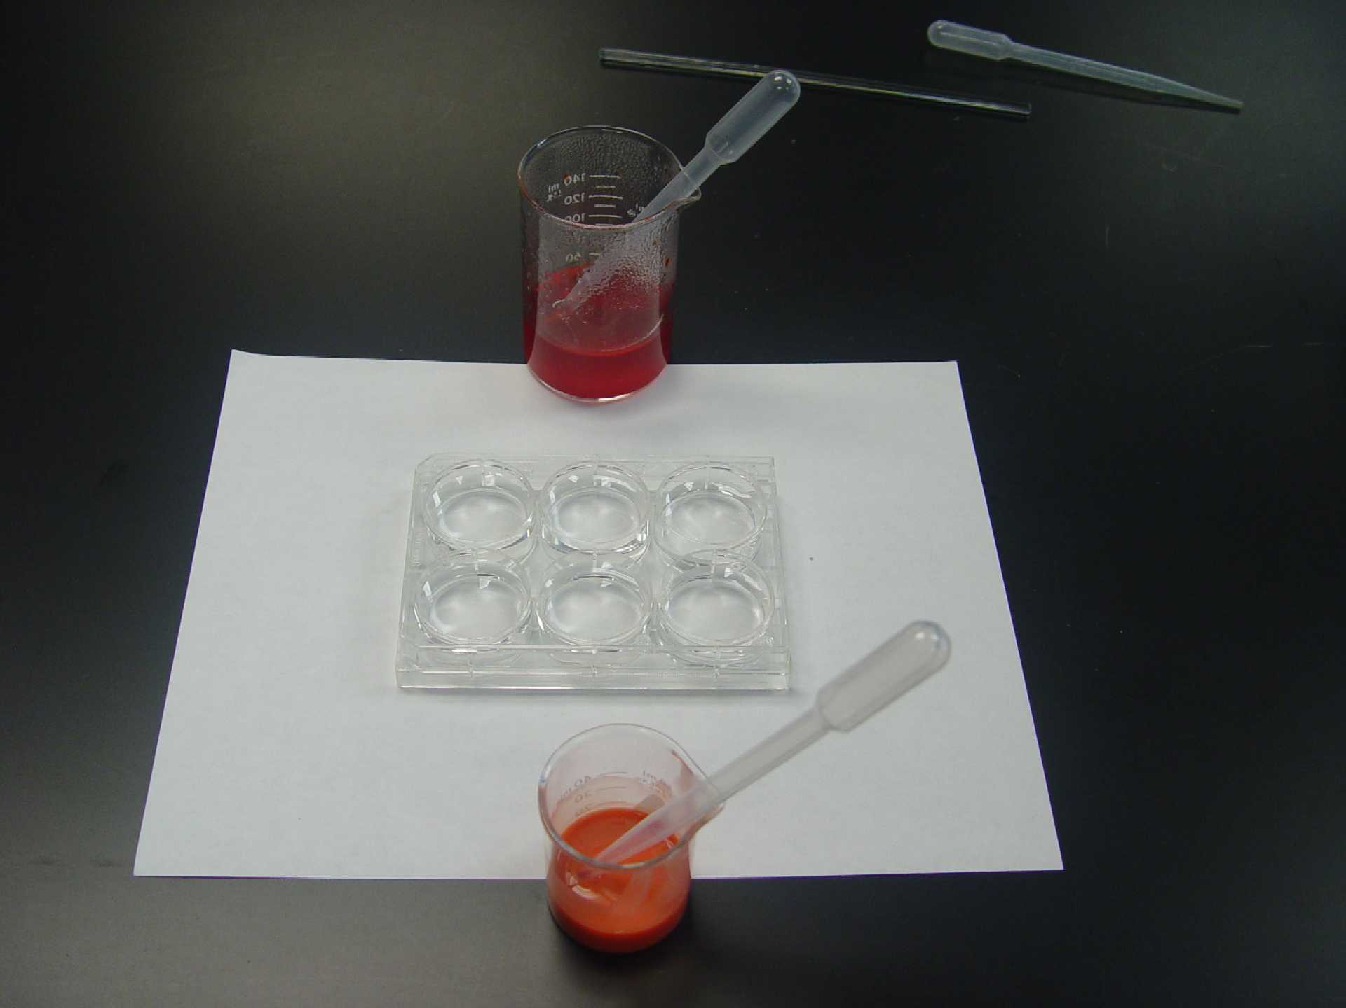
used in this activity. In the 6-well R_{x} plate,
the two left-hand wells contain 0.3 M CaCl₂,
the two middle wells contain vinegar, and the
two right-hand wells are filled with sodium
bisulfate [pH Down] solution.
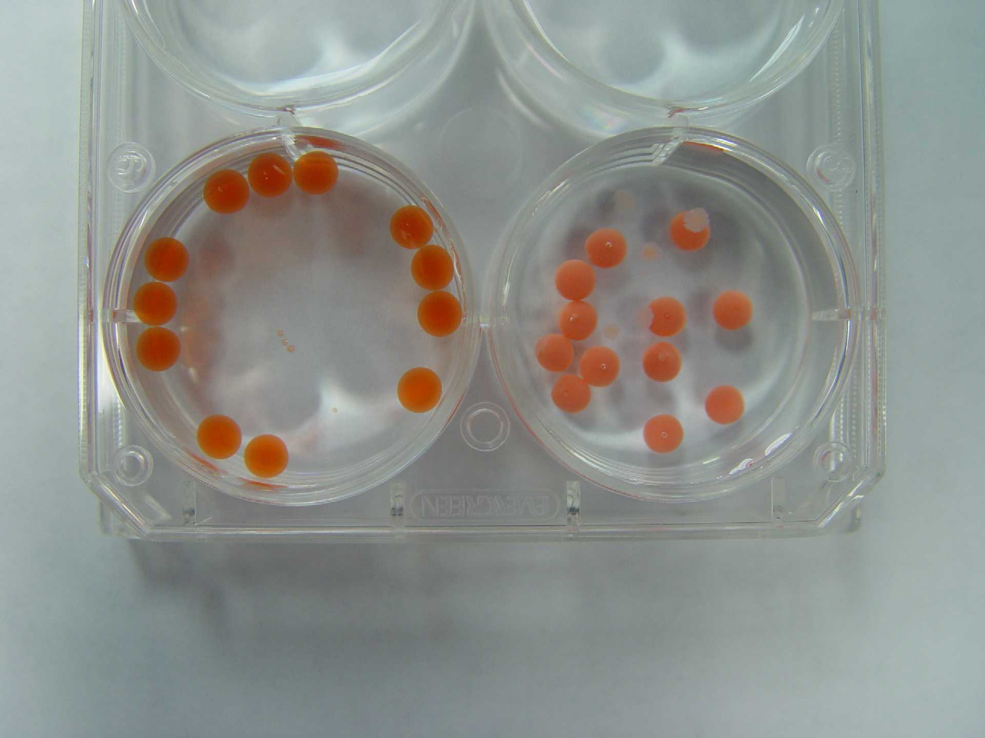
- What can be seen here are the spheres produced
by sodium alginate solution (left) and by the
Gaviscon mixture (right) after addition to the
0.3 M CaCl₂ solution. Both spheres have the
Congo red encapsulated.
- In this image, one can see the beginnings of the
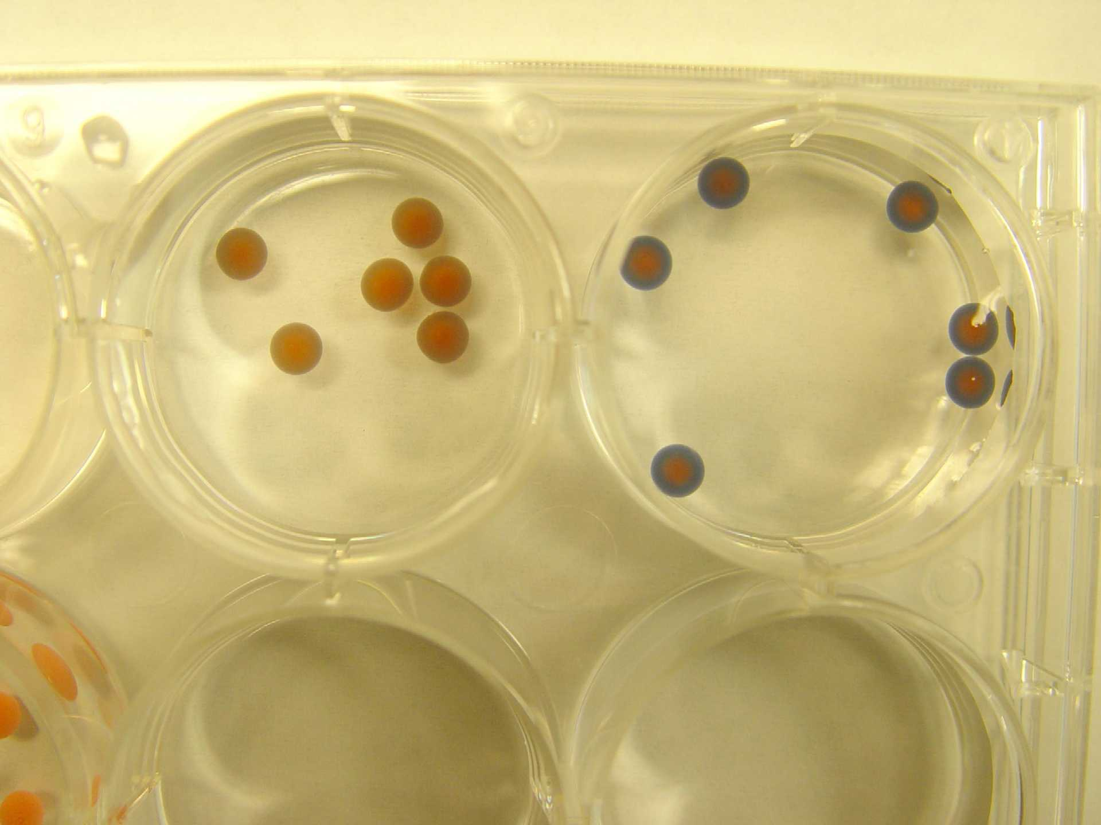
color change (to blue as a result of the use of the
Congo red) for the pure alginate spheres that have
been transferred to the pH Down solution (right).
Those transferred into the vinegar (left) have not
yet begun to change but will after an additional
minute or so.
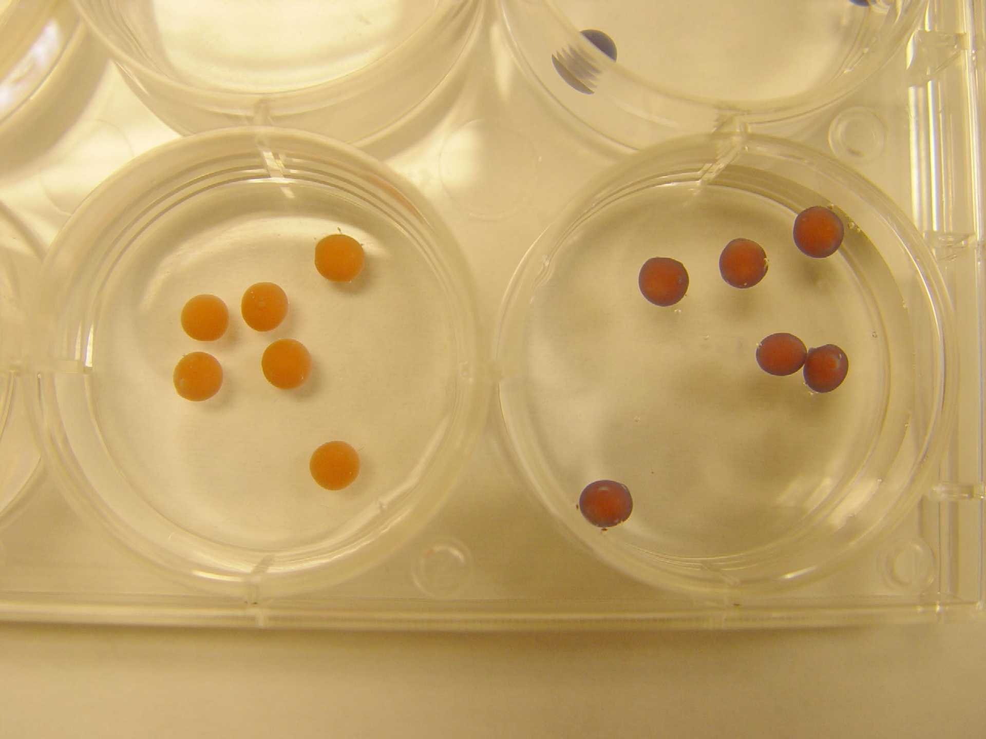
- This picture shows the beginnings of the color
change (again, to blue) for the Gaviscon spheres
that have been transferred to the pH Down
solution (right). As with the pure alginate
spheres, the ones put in the vinegar are slower to
change and do not end up at the same blue color.
- Pictured here is a focus on the Gaviscon spheres
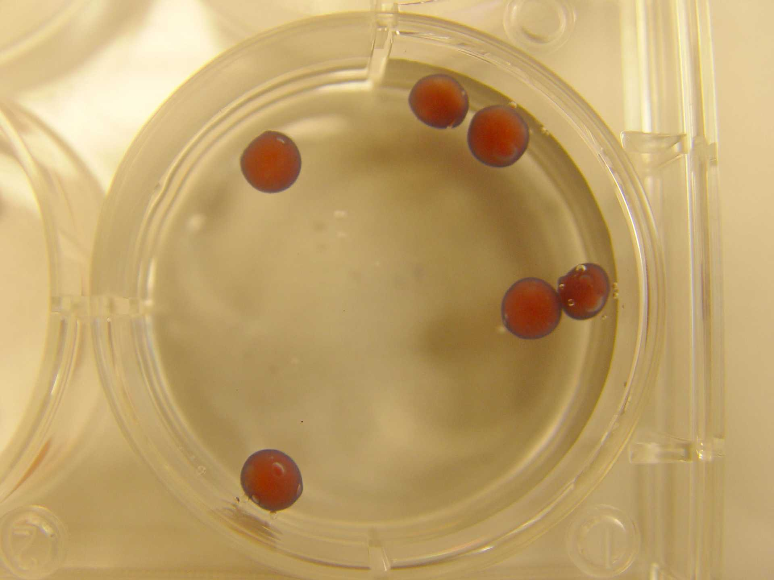
that have been transferred to the pH Down
solution. What may be noticeable – besides the
color change occurring at the outer edges – is
that the spheres are floating where they sink
initially upon being placed in this solution.
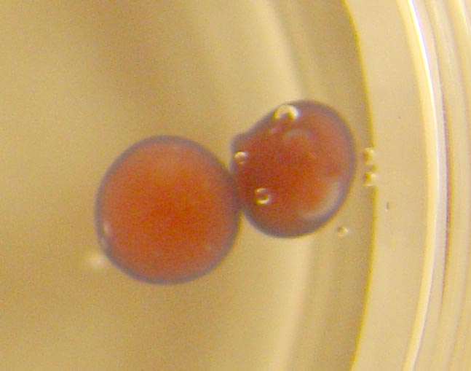
- The final picture focuses even further down on a couple of
the Gaviscon spheres that have been transferred into the
pH Down solution. One should be able to see the [CO₂]
bubbles that are beginning to be released from the spheres.

